<html>

<title>Frame</title>

<frameset cols="50%,50%">

<frame src="curriculumvitaeVer2.html">

<frame src="calendar.html">

</frameset>

</html>

**Output**

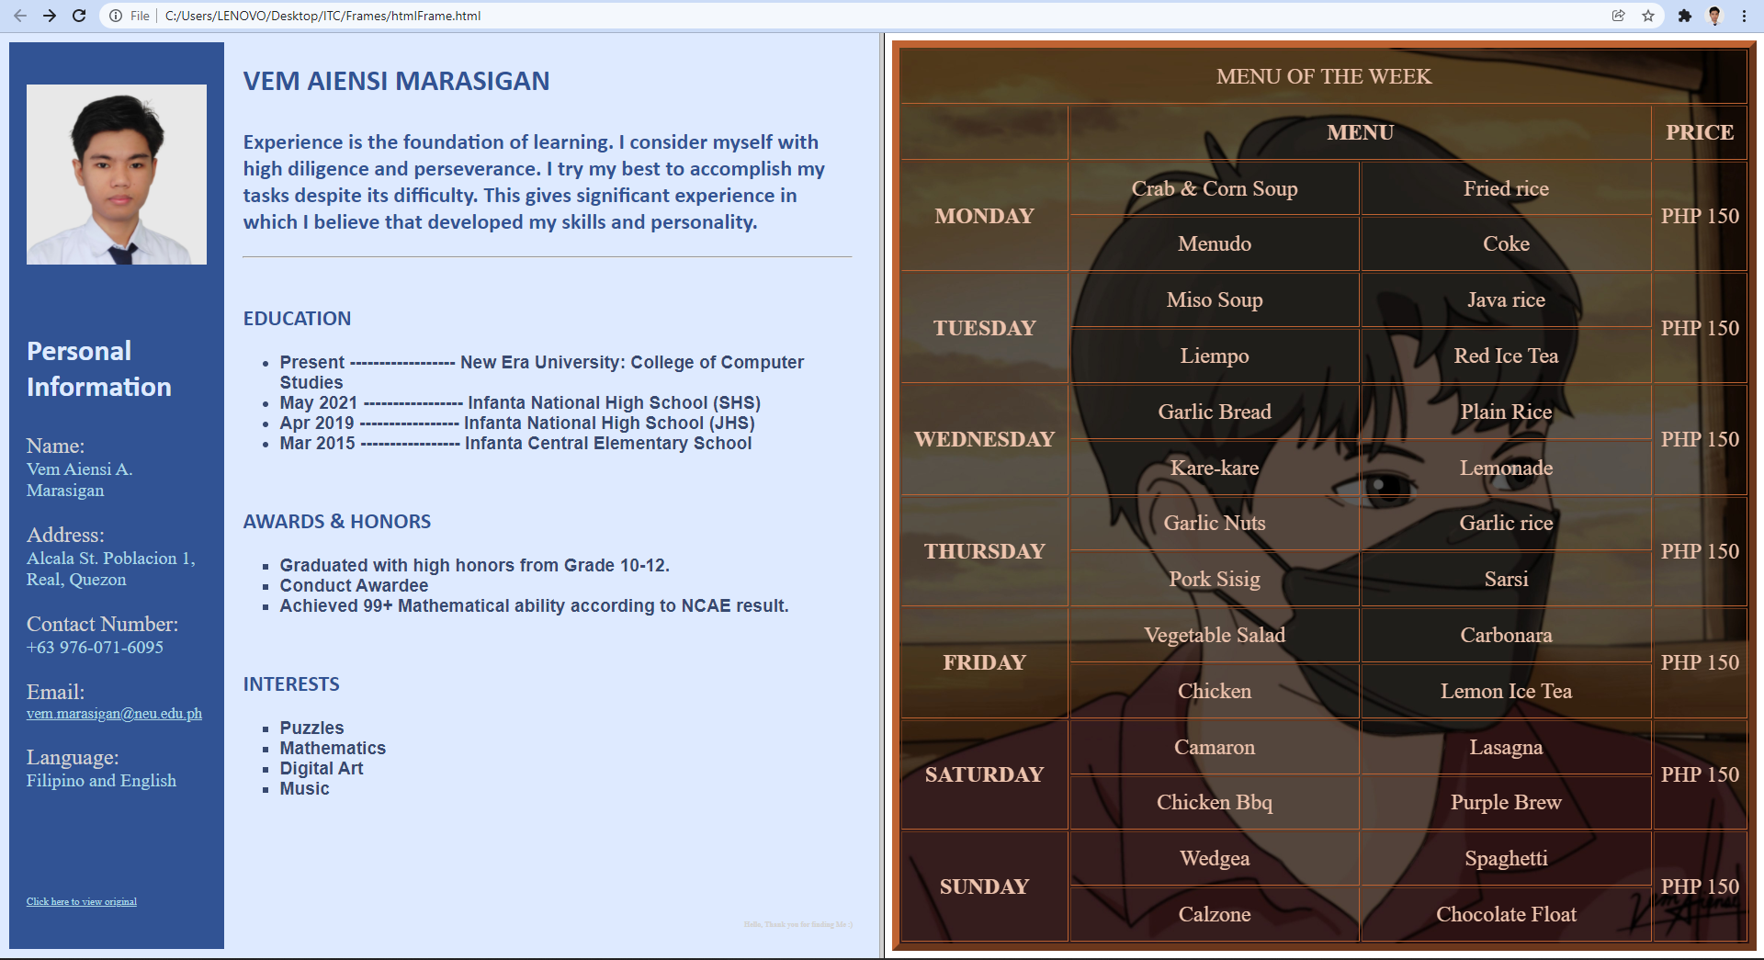

Resource files:

<https://drive.google.com/drive/folders/1R28vGZb04DY00UqyAe5MApM6DAnG1csQ?usp=sharing>

(please download the files before running. Thank You)